CLASSIFIED
Copy _____ of _____
Armor and Mechanized Infantry Task Unit
1st Battalion, 7th Cavalry Regiment
1st Armored Brigade Combat Team
1st Cavalry Division
101900CMAR18

OPERATIONS ORDER (OPORD):
JUNIPER SPEAR
BATTALION TO TASK UNIT OPERATIONS ORDER
REFERENCES:
- Intelligence (S2) and Operations (S3) Integrated Overlays
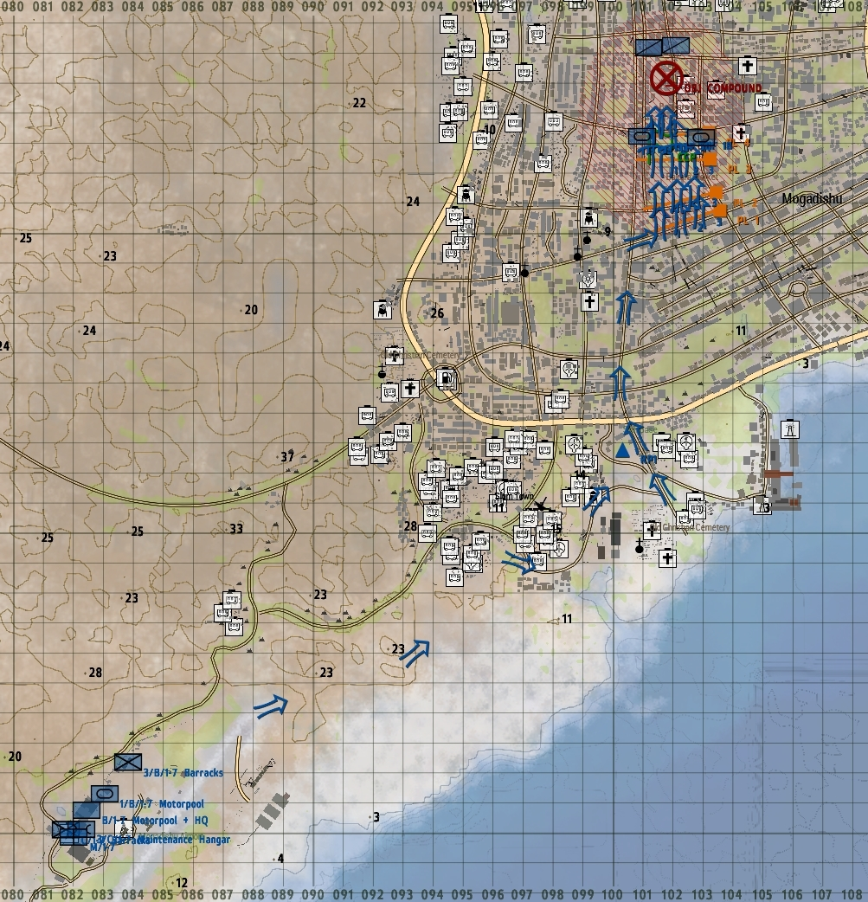
- Overlay - Objective Compound
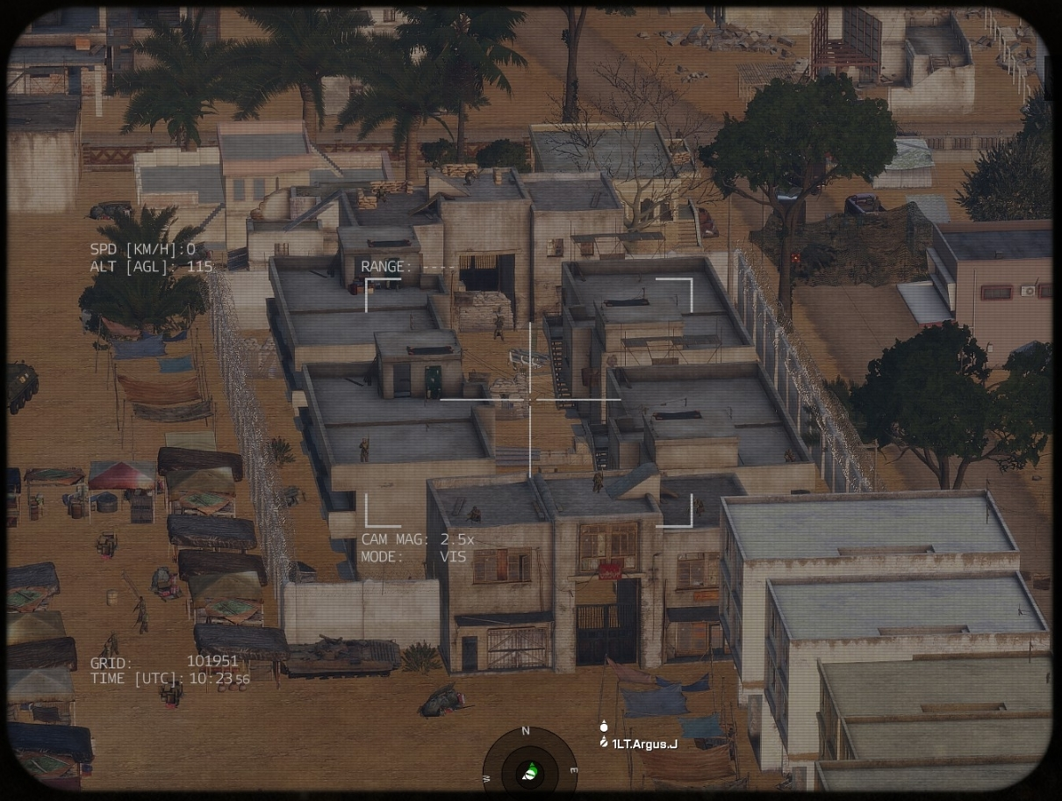
- Overlay - Objective Compound
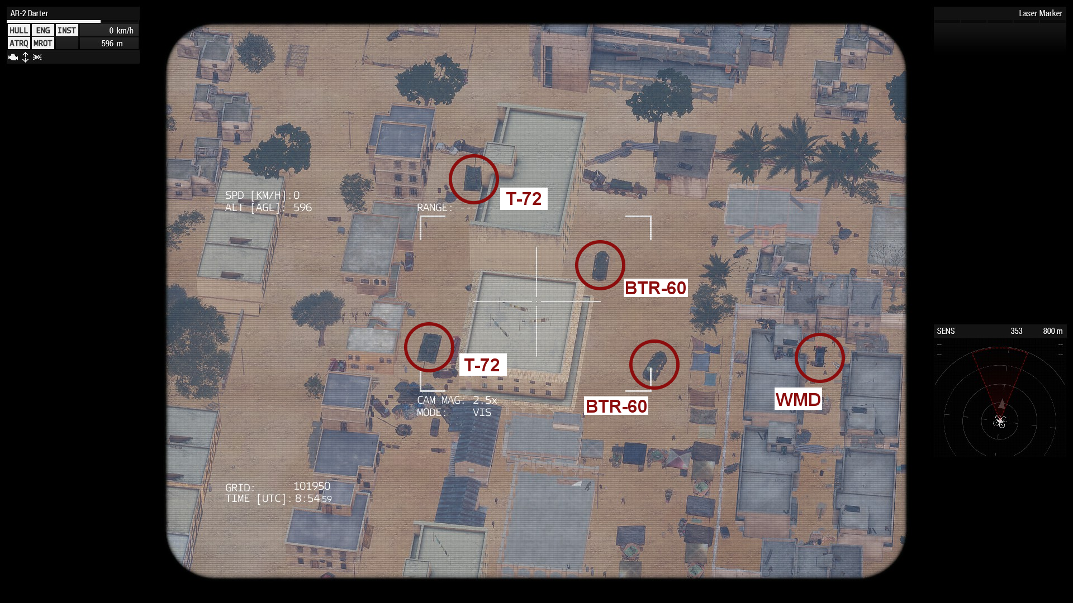

Task Organization:
Stryker Infantry Platoon:
Headquarters Section (Viking 5-6)
Motorized Infantry Platoon (Viking 1-3)
Tank Section (Saber 1-2)
Sapper Section (Havoc 1)
Medical Section (Mustang 6)
S3 Operations Section (Apollo 1, 5-6)
Ranger Section (Roughneck 6)
- Situation.
Intelligence received from high level operatives captured in prior operations has indicated that UMAR and WMD are located at a compound north of the Baakara Market in the center of Mogadishu. This information was confirmed through reconnaissance carried out using UAV.
Last night, a Ranger team was infiltrated north of the objective compound to interdict UMAR and/or WMD from escaping north as our raid on the compound is carried out.
  - Enemy Forces.
    - Weather and light data general forecast for the length of the operation:
High Temp: 45 deg C
Low Temp: 15 deg C
Sunrise: 0432z
Sunset: 1927z
Overall Weather: Light clouds and wind.
Illumination (Night): N/A
    - Terrain (OCAKA):
      - Observation and Fields of Fire (FOF) are limited for BLUFOR, and OPFOR patrolling, given the dense urban environment.
      - Cover and Concealment is good for both BLUFOR and OPFOR with a multitude of temporary, ruined, partially constructed and occupied structures.
      - Obstacles: Many of the high speed routes of approach to the objective are blockaded and the IED threat is medium.
      - Key or Decisive Terrain for this mission is indicated by phase lines 1 through 4. Much of the objective is obscured until the last 50 meters of the advance. Due to the large number of insurgents in the area, speed of advance will be critical to a successful operation.
      - Avenues of Approach for OPFOR limited as they have no additional resources in the area. The key escape route will be to the north which is currently interdicted by an in-place Ranger team.
    - Identification of enemy forces (composition). OPFOR is a guerrilla faction, and non-uniformed. S2 through US-JSOC confirms all personnel at the objectives is OPFOR. If they are armed at the objectives, or armed and patrolling, and not in SNSF they are likely hostile.
    - Location(s):
      - FOB @ 083 931 - BLUFOR (1-7 CAV).
      - RP 1 @ 100 942
      - OBJECTIVE COMPOUND @ 101 955 - OPFOR

    - Activity: OPFOR is garrisoned in, along with patrolling around, known locations. OPFOR is aware of BLUFOR presence and in a defensive posture.
    - Strength: OPFOR are heavily entrenched in the objective area and throughout the Baakara Market.
    - Probable course(s) of action when contacted: OPFOR will likely remain in place and fight, and or make first contact through movement to contact (patrols). Given high morale, if decisively engaged, they will fight to the death, and likely not to surrender. It is likely UMAR and/or WMD will attempt to exfil north.
  - Friendly Forces.
    - Mission and concept of next higher unit: The Stryker Platoon will rapidly move to Phase Line 1 and dismount. Saber 1 and 2 will isolate the right and left flank of the advance.
    - Location and planned actions of units to the left, right, front, and rear: Battalion Headquarters has been established at Mogadishu Airport, and the Task Units are moving as self-contained elements.
    - Units providing fire support:
      - Mortars: Not available.
      - CAS: Not available.
      - Artillery: Not available.
  - Attachments/Detachments.
    - Attachment: S3 and S6 detachments will accompany Air Assault Task Unit HQ to provide command and logistics support. CBRN attachments will be available once the WMDs have been seized and secured. Sapper team attached to 3rd Squad.
    - Detachment: Ranger team in-place immediately north of OBJ COMPOUND.
- Mission.
3/B/1-7 with Sabers supporting will conduct a raid on OBJ COMPOUND and if possible seize UMAR alive and secure WMD. They will then exfil back to the Mogadishu airport using the same route used to approach.
- Execution.
The intent is to establish a cordon and then assault and secure UMAR and WMD.
  - Concept of the Operation: The task unit will move along the route indicated to RP 1. A short leader’s reconnaissance will be conducted prior to moving into the city. From RP 1, the unit will move rapidly to Phase Line 1 and dismount. With armor securing the flanks, the infantry element will assault north through the Baakara Market until reaching Phase Line 4. The SBF will be established in the buildings at Phase Line 4 offering superior overwatch on the objective and flanks. Medical and Logistics elements will prepare a CCP in the rear of the SBF position. Two squads of the platoon will clear the block containing the compound and then explosively breach the compound and secure it, anyone in it and any intelligence or munitions found.
- Maneuver: The mission will consist of the following movements:
  - Movement from FOB to RP 1.
  - Movement from RP 1 to PHASE LINE 1.
  - Movement from PHASE LINE 1 to PHASE LINE 4 in PLATOON LINE with Saber units on the left and right flank roads. 1st Squad will establish itself in two buildings indicated as the SBF element at PHASE LINE 4.
  - 2nd and 3rd Squads will on command assault the block containing the compound. When secure they will explosively breach OBJ COMPOUND and secure it.
  - 2nd and 3rd Squads will retire to PHASE LINE 4 and with support elements mount in preparation for exfil.
  - 1st Squad will move from the SBF to the convoy, mount and the convoy will depart back along the route used for infil.
- Fires: N/A
  - Tasks to Maneuver Units.
- Platoon will move north from PHASE LINE 1 in platoon line, 1 on the left, 2 center, 3 right. At PHASE LINE 4, 1st will establish the SBF, 2nd and 3rd will assault the objective. A Sapper element is attached to 3rd squad to explosively breach the compound.
- Security, R&S, EPW, Aid and Litter will be handled by Apollo-1.
  - Tasks to Combat Support Units.
    - Task Unit medical level support only. Task Units must supply in field medical support.
    - Transport will be self-provided.
    - All other combat support will not be available for this mission.
  - Coordinating Instructions.
    - Order of movement, formations, and movement techniques.
      - FOB to RP 1
        - Saber 1-2: Forward Recon to OP 1
        - Viking-3
        - Viking-2
        - Viking-1
        - Mustang-1
        - Apollo-1
      - RP 1 to PHASE LINE 1
        - Saber-2
        - Viking-3
        - Viking-2
        - Viking-1
        - Saber-1
        - Mustang-1
        - Apollo-1
      - See III(A)1 for further movement instructions. Specific formations and techniques will be based on Commanders’ METT-TC assessments.
    - Actions at halts (short/long). SOP.
    - Routes (primary/alternate): N/A
    - Departure and reentry of friendly lines. N/A.
    - Rally points and actions at rally points. RPs will be established based on Commanders’ METT-TC analysis, and intelligence gathered during conduct of operation.
    - Actions at danger areas. SOP.
    - Actions on enemy contact. React to Contact. Execute appropriate battle drill.
    - Reorganization and consolidation instructions. Consolidate on objectives if possible.
    - Fire distribution measures. SOP.
    - Fire control measures. Engage the greatest threat first.
    - MOPP levels. MOPP Ready.
    - Troop safety and operational exposure guidance. Nuclear radiation may be present around the WMDs. Likelihood of triggering WMDs low, although they may be trapped. Use extreme caution.
    - Time schedules (rehearsals, backbriefs, inspections, movement). TBD.
    - Priority Intelligence Requirements (PIR).
      - OPFOR composition and capabilities.
      - Locations of IEDs, VEIDs, and other ambush sites.
      - Location of WMDs and/or Umar.
    - Debriefing requirements. See PIR above.
    - Reports. ACE and SALUTE reports after all OPFOR contact, SALUTE upon observation of all OPFOR.
    - Rules of Engagement (ROE). Civilians may be present. PID all targets before engaging. Any show of hostile action or intent is justification for engagement.
- Service Support.
  - General.
    - SOPs in effect for sustainment operations. None.
    - Current and proposed trains/resupply/cache points.CCP at PHASE LINE 4..
    - Casualty and damaged equipment.
      - CCPs to be established by Mustang-6.
    - Special instructions for medical personnel. High tempo operation CCP designation. Coordinate with Apollo to synchronize CCP and resupply action.
  - Material and Services.
    - Supply:
      - Class I: SOP.
      - Class II: SOP.
      - Class III: SOP.
      - Class IV: N/A
      - Class V: Ammunition will be resupplyable via APOLLO in MRAP.
      - Class VI: N/A.
      - Class VII: SOP.
      - Class VIII: SOP.
      - Class IX: SOP
      - Class X: N/A.
      - Distribution Methods. Ammunition will be resupplyable via APOLLO in MRAP.
    - Transportation.
      - Ground. MRAPs for supply and reinsert via Apollo Team.
      - Air: Not available.
    - Services. SOP
    - Maintenance (weapons, equipment, vehicles). N/A.
  - Medical Evacuation: Casualties need to be treated in field. In event of critical wounded, CASEVAC will be provided by MRAP back to COP.
  - Personnel:
    - All reinserts will be coordinated through S3 Officer in Charge (Apollo) and Apollo units.
    - All EPWs will be detained, searched, and cleared of all weapons and equipment and left at CCP (location TBD).
  - Miscellaneous:
    - Special equipment. Satchel charges for explosive breach.
    - Captured equipment. Destroy in place, unless strange or unique. In case of strange or unique, case with or if can’t be moved make a sketch and destroy it.
- Command & Signal.
  - Command.
    - HHC 1ABCT is based out of FOB [Classified], Kismayo.
    - Battalion CP located at AMogadishu, Somalia.
    - Task Unit CP is located at FOB (Grid 083 931)
    - Succession of Command.
      - S3 Officer in Charge (Apollo-6)
      - Infantry Platoon Leader (Misfit-6)
      - Infantry Platoon Sergeant (Misfit-7)
      - Aviation Element Leader (Pegasus)
    - Adjustments to the unit SOP. None.
  - Signal
    - SOI. Standard SOI per Battalion.
    - Method of communication by priority. Short-range radio, Long-range radio, runner.
    - Pyrotechnics and signals. SOP + SL & up fix IR strobes during CAS
    - Codewords. None.
    - Challenge and password (behind friendly lines). Log / Ticket
    - Number combination (forward of friendly lines). 24
    - Running password. Garry Owen.
    - Recognition signals (near/far, day/night). Any combination of 3 lasers.
    - Special instructions for RTOs. None.

AUTHENTICATION CPT Argus, J.
S3 Officer in Charge

